Name: _________________________________________

Flow Diagram for ocean carbonate chemistry

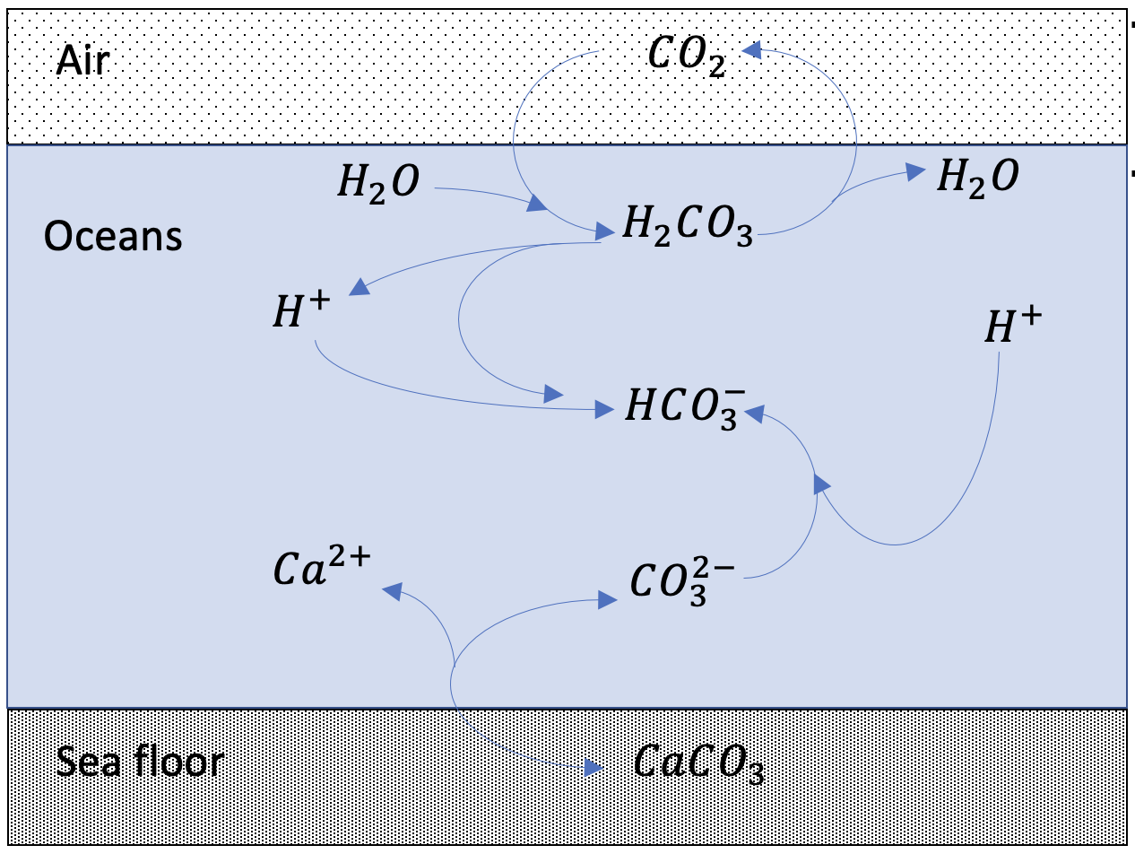

Reagents and supplies:

* Sea water
* 250 mL Erlenmeyer flasks (each student)
* Universal pH indicator
* CO2(g) (from a cylinder)
* Sodium or Potassium Carbonate (powder)
* Calcium Carbonate (powder)
* Hydrochloric Acid (aqueous)

**Step 1 – pH of water**

Measure out about 100 mL of sea water into an Erlenmeyer flask. Add a few drops of pH indicator. What’s the pH? Is sea water acidic or basic?

**Step 2 – Effect of dissolved CO2**

Bubble some CO2 through the water in your flask. What’s the pH now? The reaction you just carried out can be expressed as

$$CO_{2}+H_{2}O→H_{2}CO_{3}$$

followed by

$$H_{2}CO_{3}→H^{+}+HCO_{3}^{-}$$

which ***releases $H^{+}$*** , and therefore should make the solution **more acidic** (did it?). Circle these reactions and label them as “Step 2” on your flow diagram.

**Step 3 – Effect of carbonate ion ($CO_{3}^{-}$) on pH**

Add a little Sodium or Potassium Carbonate to your flask What’s the pH now? The reaction you just carried out can be expressed as

$$CO_{3}^{2-}+H^{+}→HCO_{3}^{-}$$

which ***consumes $H^{+}$*** , and therefore makes the solution **less acidic** (did it?). Circle this reaction and label it as “Step 3” on your flow diagram.

**Step 4 – Properties of Calcium Carbonate ($CaCO_{3}$)**

Empty out your flask, then add tap water and a few drops of pH indicator. Now add a little Calcium Carbonate to your flask. What’s the pH now? How does it compare to the pH of ocean water? Does it look like the carbonate is fully dissolving? The reaction you just carried out is

$$CaCO_{3}^{}→Ca^{2+}+CO_{3}^{2-}$$

Circle this reaction and label it as “Step 4” on your flow diagram.

**Step 5 – A super-acidified ocean**

Add some concentrated Hydrochloric Acid to your flask. What’s the pH now? Does it look like the calcium carbonate is dissolving?